**SOUTHERN LEYTE STATE UNIVERSITY**

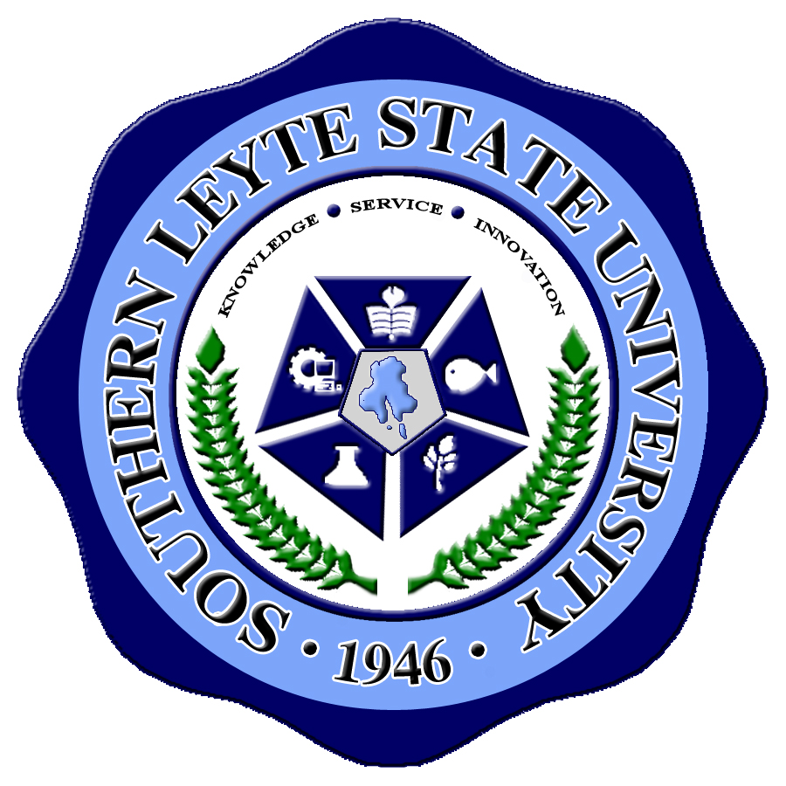

Main Campus-Sogod, Southern Leyte, Philippines

***offers***

**DOCTOR OF PHILOSOPHY in TECHNOLOGY MANAGEMENT**

***and***

**MASTER OF ARTS IN TEACHING**

major in: English Language

Mathematics

Natural Science

Filipino

**MASTER IN TECHNOLOGY EDUCATION**

**MASTER IN MANAGEMENT** (Non-thesis)

For queries, please visit or contact the SLSU-Sogod GS Office thru:

Telephone No: 053-382-3294; Cellphone No.: 09161822437

Email address: gs.slsumain@gmail.com

**ENROLLMENT** for the **First Semester of AY 2014-2015 is on-going**.

**CLASSES** will start on **June 21, 2014**

**ENROLL NOW!!!**